# Mere Mortals Chapter 7

## Tyler Burleson

## Sales Orders Database

1. *“Show me the customers and employees who have the same name.”*

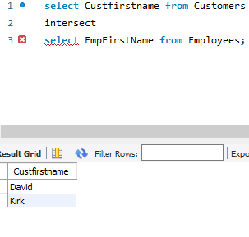

1. *“Show me the customers whose names are not the same as any employees.”*

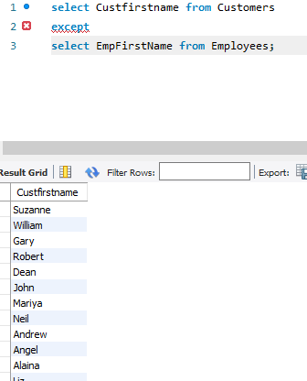

1. *“Show me all the customer and employee names and addresses.”*

## 

## Entertainment Agency Database

**1.** *“List the entertainerIDs who played engagements for customers Bonnicksen and Keyser.” 10014 10011*

1. *“List the entertainerIDs who played engagements for customers Bonnicksen but did not play any engagements for customer Keyser.”*
2. *“List all the entertainerIDs who played engagements for customer Bonnicksen combined with all the entertainerIDs who played engagements for customer Rosales.”*

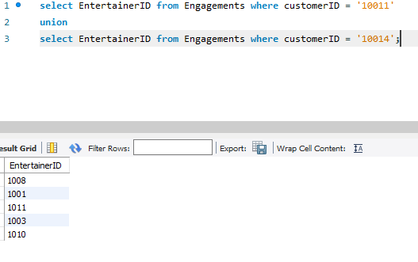

## Bowling League Database

**1.** *“Find the bowlerIDs who had a raw score of 155 or better at Thunderbird Lanes(9) and Bolero Lanes(10).”*

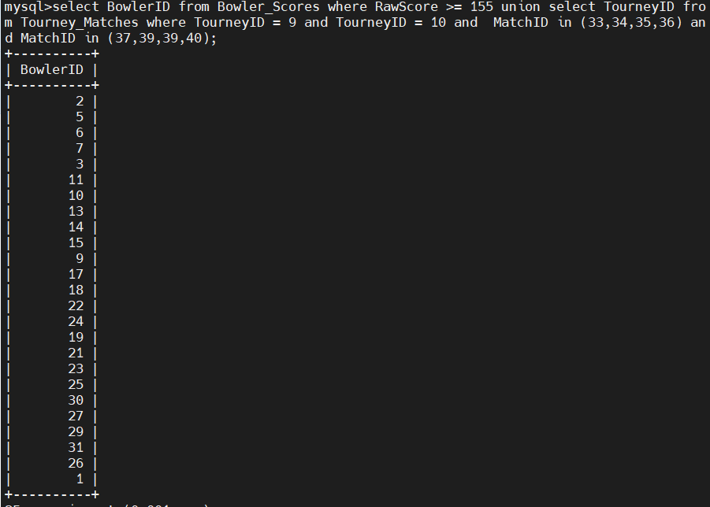

**2.** *“Find the bowlerIDs who had a raw score of 155 or better at Thunderbird Lanes but not at Bolero Lanes.”*

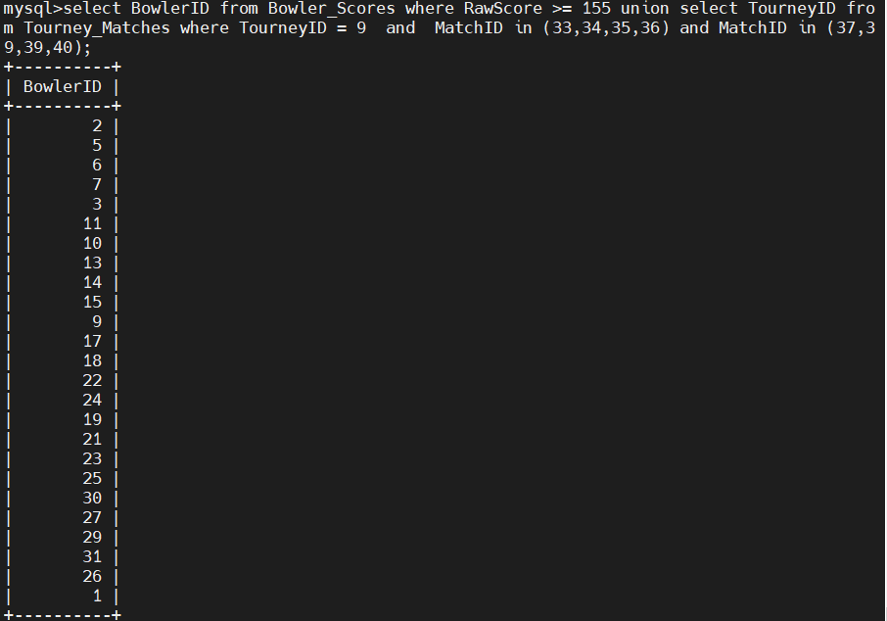

## Recipes

**1.** *“Show me the recipeIDs that have beef (1) but not garlic (9)”*

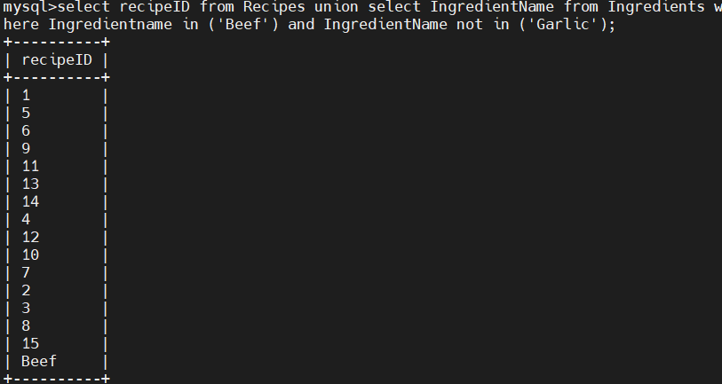

1. *“Show me the recipeIDs that have beef (1) and garlic (9)”*

